**Progress Report Week 2**

**Group Name: Anhinga**

**Part I: Fiber orientation analysis:**

Exploring the data: The reconstructed micro-CT scan was stored in a scanner native format (.txm). The reconstructed volume has the grid dimensions of $1008×1024×1004$, a voxel size of0.00443597 $4.44⋅{10}^{-3}×4.44⋅{10}^{-3}×4.44⋅{10}^{-3}mm$ (physical unit), and the intensities stored in a uint8 bit-representation in the range from 0 to 64822.

Crop-out: The initial analysis is done in a smaller crop-out of size $400×400×400$. The position of the crop-out is shown in Figure 1.

**Figure 1:** Crop-out from the reconstructed micro-CT scan.

Gradient calculation: The gradients in x and y direction in all voxels are computed using a sobel filter. The results are shown for a selected slice in Figure 2.

**Figure 2:** Slice number 200 from the crop-out along with the gradients in the x and y.

Orientation analysis: The magnitude and the angle relationship between the gradients are computed for every voxel using the following formulas.

* Magnitude: $\sqrt{Vx_{sob}^{2}+Vy_{sob}^{2} }$
* Angles: $arctan2{(Vy_{sob}},Vx_{sob})$

The angles are converted to an RGB colormap, and both the magnitude and angular maps are exported for visualization using ITK-SNAP (see Figure 3).

**Figure 3:**Example of slice (200): Left: Gradient magnitude, Right: Gradient direction.

We classify a voxel as either being horizontal or vertical if:

* The gradient magnitude is above 16000
* The angle is +/- 0.5 / [1,2] radians from the respective vertical / horizontal axis.

The volumes and volume ratio are determined, and the classification result is visualized in Figure 4.

The volume of horizontal fibers: $0.3229mm^{3}$

The volume of vertical fibers: $2.102mm^{3}$

The ratio: $\frac{ 0.3229mm^{3}+2.102mm^{3}}{3.162mm^{3} }=0.76$

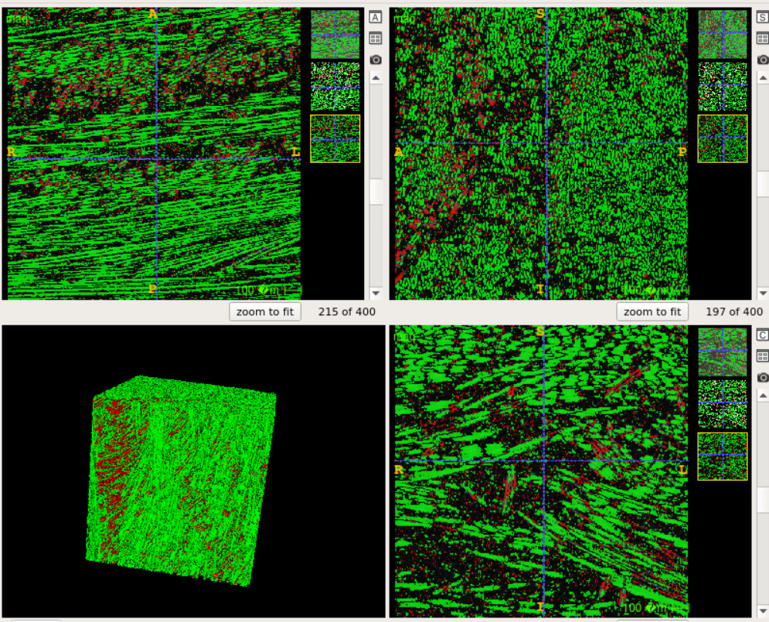

**Figure 4:** Segmentation results

**Part II.I: CUB_200_2011 - bird classification using CNN:**

Exploring the data: The CUB_200_2011 is an open benchmark dataset consisting of 11788 natural images of 200 classes of birds. A few example images are given in Figure 5.

**Figure 5:** Example image from train - and test loader.

Data transforms: The input images have varying dimensions and aspect ratios. We therefore apply the following data transforms to standardize the input: padding, normalization, resizing & cropping.

Testing a CNN model for classification: The model consists of X. Describe the network model and other hyper-parameter choices (activation functions, loss functions, optimizer, batch size, epochs).

The training and test loss curves are shown in Figure 6. We see that describe the result (e.g. final accuracy).

**Figure 6:** Training and testing loss curves and accuracy curves.

**Part II.II: Bird classification using CNN and data augmentation:**

Dataset: DTUB_213_F24.

The CNN model is identical to the described in Part II.I. The difference is that data augmentation is applied to the training images. The following augmentation transforms are applied:

* Color Jitter
* Vertical Flipping
* Horizontal Flipping

The training and test loss curves are shown in Figure 6. We see that the model is no longer overfitting to the training data. The training and testing loss curves are much more similar, and the generalization gap is much smaller. The same is observed for the accuracy. Due to the augmentation the training data is now more complex, thus the model needs more epochs to learn the features. We see that the testing loss converges after approximately 80 epochs where the testing accuracy is approximately 6% .

**Figure 6:** Training and testing loss curves and accuracy curves with augmentation.

Performance analysis on class Anhinga: The prediction accuracy on birds from class Anhinga was 0. Examples of misclassified test images from the class are shown in Figure 7. The class is twice mistaken for class Curlew otherwise the remaining 12 test images are classified as 12 different classes. The Anhinga is most often misclassified as other birds with long neck placed near water.

**Figure 7:** Examples of Anhinga classified as Curlew.